**UNIVERSITY OF ESSEX**

**DEPARTMENT OF ECONOMICS**

**MSC IN FINANCIAL TECHNOLOGY (COMPUTER SCIENCE)**

**TERM PAPER FOR EC911-7 Computational Market Microstructure for FinTech and Digital Economy**

By

Emmanuel Olaoye

[EO19181@essex.ac.k](mailto:immanj@essex.ac.uk)

Suvervisor: Professor Sheri Markose

Lecturer: Roxana Mohammadian-Molina.

1. Introduction  
  
Market microstructure, a vital aspect of modern financial ecosystems, undergoes continuous evolution, propelled by technological advancements. This paper delves into the intricacies of London Electronic Order Book, exploring its key elements such as the limit order book, winner determination rules, walking the book, VWAP, iceberg orders, and fill or kill. By leveraging insights from relevant literature, we aim to comprehend the challenges posed by high-frequency algorithmic trading, introduces major strategies and discus its pros, cons, and associated risks. The theory section introduces the Malik-Markose method, focusing on the changing shape of demand/bid and supply/ask curves. Subsequently, we utilize this method to construct demand and supply curves, analysing their impact on market dynamics. The exploration extends to price impact methodology, emphasizing how order book information predicts price trends. Concluding the paper, we summarize key findings, reflect on their implications for market microstructure and trading strategies, and propose avenues for further research.

# 2. Overview of London Electronic Order Book:

The London Electronic Order Book plays a pivotal role in modern financial markets, acting as a dynamic database that orchestrates the intricate dance between buyers and sellers. Within this electronic ecosystem, unexecuted orders are meticulously organized, with traders indicating their intentions to either buy or sell a stock at specified price levels. Bidders express their interest by placing orders to buy at or below a particular price, while sellers articulate theirs by placing orders to sell at or above a specified price. The orchestration begins at the *Top of the Book*, where the best bid price, in this case, £9.27, and the best ask price, £9.30, establish the starting point. The difference of 3p between these values forms the *Bid-Ask Spread*, reflecting the cost a trader incurs if they buy and immediately sell a stock—a *Round Trip Transaction* cost of 3p.

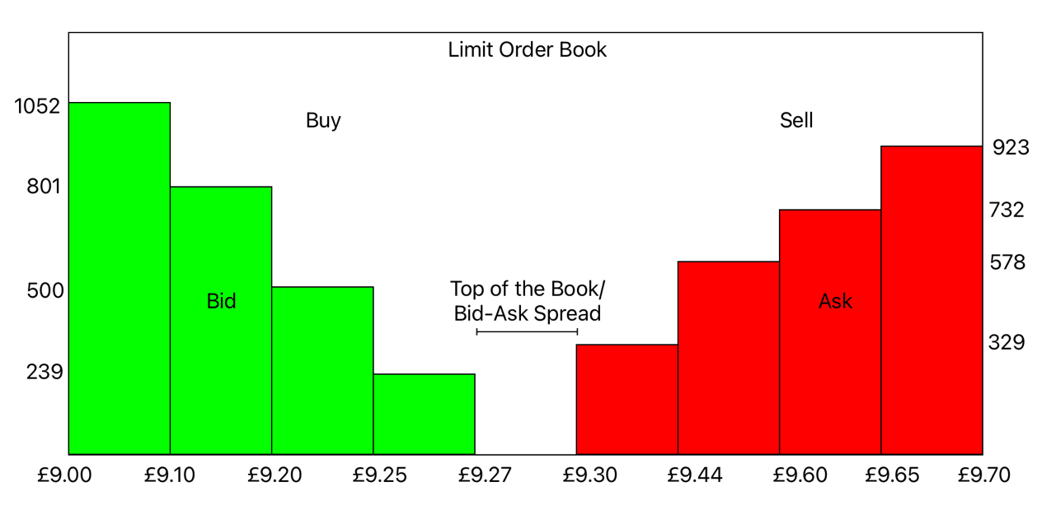

Figure 1 Graphical Example of a Simple Limit Order Book

The limit order book comprises three fundamental operations. Traders can initiate a new order to place it in the order book. Upon placement, they receive an order ID, enabling them to either cancel the order entirely or remove the remaining portion if it has been partially filled. Additionally, traders can modify their orders by submitting a set of instructions known as cancel/replace.

|  |  |  |  |
| --- | --- | --- | --- |
| Buy Orders | | Sell Orders | |
| Bid Price | Quantity | Ask Price | Quantity |
| £9.27 | 239 | £9.30 | 923 |
| £9.25 | 500 | £9.44 | 732 |
| £9.20 | 801 | £9.60 | 578 |
| £9.10 | 1052 | £9.65 | 329 |
| Table 1 Graphical Example of a Simple Limit Order Book | | | |

The Limit Order Book operates in a constant state of flux as new buy and sell orders flood in, shaping the ebb and flow of market dynamics. Traders have the agency to adjust their positions, and orders can be promptly removed from the book if a trader wishes to cancel them. This dynamic environment accommodates various order types, each tailored to different trading preferences. A Market Order is executed immediately at the best available price, while a Limit Order is activated only when the stock reaches a predetermined or more favourable price. The *Stop Order* adds a conditional layer, triggering a market order only when a specific price threshold is breached. Additionally, Partial market executions occur when trades are executed for less than the specified order size.

Within the realm of order priority mechanisms, Price-Time Priority ensures that, when multiple orders are present at the same price level, the earliest placed order takes precedence and secures the best available price incentivising traders to place the orders as early as possible. Complementing this, some limit order books employ Price-Size Priority dictates that orders with higher quantities receive priority in the order book.

The market's operational protocols extend to order types such as "Kill or Fill," a directive specifying that an order must be filled in its entirety or cancelled. Traders wielding Market orders with volumes surpassing the best price engage in the practice known as "walking the book." In this strategy, a portion of the order is initially executed at the best price, and the remaining portion is filled at the next best available price. For example, looking at Table 1 if a Trader wishes to buy at market price for 1500 shares he will first get 923 shares at £9.30 and the remaining 568 shares at £9.44. This nuanced approach allows traders to navigate the market with flexibility and efficiency.

Beyond traditional order types, traders employ sophisticated strategies like iceberg orders to conceal their full intentions. Iceberg orders cleverly break down large orders into smaller, less conspicuous portions. The impact of iceberg orders on market liquidity is profound, as other participants, upon discovering these orders, are compelled to follow suit at execute similar strategies. Frey and Sandås (2009) elucidate this cascading effect in their exploration of iceberg orders. They find that iceberg orders impact price and order flow dynamics, attributing this to a signalling effect influenced by detectability and the submitter's control over peak size. They raise questions about the choice between iceberg orders and dynamic submission strategies, emphasizing the need to understand optimal peak size. Similarly dark pools which are private exchanges used to limit the market impact of large intuitional trading firms. Traders in dark pools do not have to publicly show the price of their order not their quantity until there have been made executed (Zhu, H. (2012)).

There is a lot of empirical evidence supporting the use of the contents of the limit order book with Price discovery. Zheng et al (2013) investigated the information such as the limit order volume, limit order price gaps, market order information and the limit order event information are extracted and then a LASSO logistic regression is applied to predict future Price Jumps which are defined as a “*sell (buy) market order arrival which is executed at a price which is smaller (larger) than the best bid (best ask) price at the moment just after the precedent market order arrival.”* The researcher analysis was based off the largest 40 largest Frech banks from the CAC40 using intraday trading data based on morning (between 09h05 and 13h15) and afternoon (between 13h15 and 17h25) datasets. across all datasets the inter-trade price jump prediction could be made around 70% of the time.   
  
Similarly based off the Berkowitz et al (1988) proposed metric for measuring the execution cost of the market impact or (execution cost) over a trading day Volume-Weighted Average Price (VWAP), $$VWAP(Volume Weight Adjusted Price)= \frac{Value of Trades (\$)}{Volume of Shares for Traders}$$ 
  
 the researchers Malik and Markose (2012) proposed a new metric Notional Volume Weighted Price (NVWAP) which measures “the change in the shape of empirical liquidity supply and demand curves” by applying nonparametric kernel regression. By constructing NVWAP curves and the subsequent change in the behaviour of liquidity supply and demand, the researchers found observable patterns in the Liquidity supply and demand curves which can be used find future price movements to subsequently be used and in a Hight-frequency trading system (discussed more in section 3) as market indicator.

# 3. Challenges of High-Frequency Algorithmic Trading:

Throughout history, trading has played a ubiquitous role in human evolution. From the exchange of commodities like cattle or wheat for gold to the sophisticated security exchanges in the financial sector today, the concept of trading has continuously evolved. The origins of these exchanges can be traced back to 14th-century European moneylenders, where Venetian lenders brokered deals for various items with the public (Mueller, R.C., 1998). Records of the Belgian government's stock exchange date back to the 16th century, involving brokers and moneylenders conducting transactions with businesses and the government using promissory notes and bonds, as formal shares in companies did not yet exist (Smith, B.M., 2004). Companies like the Dutch East India Company began providing shares and paying dividends based on the success of their voyages, leading to increased competition and demand for shares (CITATION). This historical progression eventually led to companies issuing stocks and bonds, culminating in the establishment of London's first Stock Exchange (LSE) in the late 1700s. Initially, buyers and sellers exchanged bids and ask prices by vocalizing them. However, with the advent of computers, the traditional method was replaced by Algorithmic Trading, where computer algorithms, either semi-autonomous or fully autonomous, govern the buying and selling of shares. This evolution, driven by the speed and precision of computers, has given rise to High-Frequency Trading (HFT), characterized by the rapid execution of thousands of trades at speeds surpassing human comprehension.

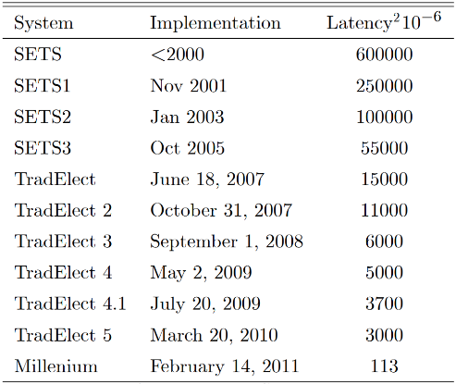

Figure 2: Table of The Evolution of The London Electronic Order Book (Linton, O. and Mahmoodzadeh, S. (2018))

Since 2009, high-frequency trading accounts for 75% of all trading done in the US (Hendershott, 2009; others estimate it to be closer to 50% - Anatoly B. Schmidt, 2011). Traders can now automate any trading strategy faster and more accurately than before and can employ even more sophisticated and complex strategies that were previously not possible. The need for HFTs started in the 1960s, where the NYSE experienced an increase in trading which led to a huge backlog of paperwork, slowing down efficiency and leading to fewer trading hours (citation). Since then, the trading volume is less than 1% of what it is today. Jones (2013) argues that these developments have led to a lower bid-ask spread and decreased the cost of trading for retail investors.

**HFT Strategies**

HFT firms employ various strategies, including market making, arbitrage, statistical arbitrage, cross-venue/cross-asset arbitrage, and news/semantic trading.

**Market Making**

A Market Maker is a firm that continually stands ready to buy and sell a particular stock at a publicly quoted price. The firm may incur losses on its inventory but profits are made by capturing the bid-ask spread. Traditionally, large institutions held a monopolistic grip on market making, offering daily prices and leaving the public to seek competitive rates. The advent of fast algorithms disrupted this, as they could process orders swiftly, leading to a decrease in tick size (the minimum price increment of stock) from 0.125c to 0.01c in most stocks. Moreover, these algorithms could always quote the best prices without charging fees, unlike traditional institutionalized firms. However, heavy competition exists, as speed is crucial for profit, and buy and sell offers need to be executed promptly.

**Price Arbitrage**

Since trading firms quote hundreds of stocks and securities daily, they can generate theoretical values for options. If the price of an option deviates from its theoretical value, HFT algorithms will buy or sell the option to manipulate its value toward the "correct" theoretical value. In doing so, the trading firm finds profit (finding edge) and secures profit from hedging their exposure with the future contract of the option (Anatoly B. Schmidt, 2011).

**Statistical Arbitrage**

Statistical arbitrage is a market strategy that exploits inefficiencies in the pricing of groups of stocks. This strategy involves buying a group believed to be undervalued and selling a group believed to be overvalued, assuming that the discrepancies will realign in the future (mean reversion). For instance, if a trading firm tracks a company selling paracetamol and another selling ibuprofen, the share prices of these two companies are usually strongly correlated. If the share price of the ibuprofen company veers away from the paracetamol share price, the trading firm will buy ibuprofen and sell paracetamol, assuming the share prices will realign. While categorized as a form of arbitrage, this strategy is not risk-free, especially if the share price of the paracetamol company goes bankrupt. Traditionally, these inefficiencies lasted from minutes to days, but HFT algorithms operate in milliseconds to microseconds.

**Other HFT Categories**Other HFT categories include semantic trading (news-based trading), where algorithms scrape news sites, social media, and company press releases to quantify overall sentiment and execute trades faster than humans can read headlines (Nasseri, A.A., Tucker, A., and de Cesare, S., 2015). Direction-based trading anticipates short-term price movements in stock (and forex markets - Mabrouk, N. et al., 2022) using market data and other information sources. Profit is sought by buying when prices are predicted to rise and selling when a decline is anticipated. Various investment funds have employed momentum and contrarian strategies at different frequencies, with outcomes varying in terms of success, as observed by Khandani and Lo (2007)

**Speed**The primary determinant of success for all HFT strategies is speed. Many observed arbitrage opportunities (Budish, Cramton, and Shin, 2015), inefficiencies, and entry points in these strategies for algorithms only appear for less than a microsecond (Duhigg, C., 2008). Failing to enter and exit these positions swiftly can result in massive losses. To prevent this, many HFT firms host their servers in the server room of exchanges at a high premium. Larger firms have also invested in deep-sea cables to connect to exchanges across continents, reducing latency to nanoseconds and approaching the limit of the speed of light. This is why trading firms are opting to use microwave towers for communication, as light travels through the air faster than through fiber optic cables (Goldstein, J., and Nost, E., 2022). On the server side, algorithms need to be as efficient as possible to take inputs efficiently and discern whether to buy, sell, or hold (Anatoly B. Schmidt, 2011; Cliff, D., Brown, D., & Treleaven, 2011). HFT firms invest millions in hiring the best quantitative and systems developers (Fitch, 2020) to optimally program these algorithms and minimize the response time.

**Profitability**There is ample empirical evidence suggesting that HFT is a profitable sector. The Tab Group (2012) estimates that in 2008, HFT firms profited $20 billion by making small profits, often as low as 0.1c on each trade. Research by Kearns, Kulesza, and Nevmyvaka (2012) using the Omniscient Trader Methodology found that the potential profits strategy was estimated at around $2 billion, with recent competition further reducing potential profits (Chordia, Green, and Kottimukkalur, 2016).

**Price Discovery**(Oliver Linton) investigated Hendershott (2012), who explained the concept of price efficiency and argued that High-Frequency Trading (HFT) might enhance market efficiency by facilitating price discovery through information dissemination. Linton also found further research by Brogaard, Hendershott, and Riordan (2014), suggesting that HFT contributes positively to price efficiency by trading in the direction of permanent price changes and against transitory pricing errors on average days and highly volatile days. While negative effects on efficiency may arise from manipulative strategies, a competitive HFT industry is seen as promoting market efficiency by making it more challenging for efficiency-reducing strategies to be effectively implemented. Various studies (Castura et al., 2010) indicate that the growth of computer-based trading, including HFT, has generally improved price efficiency in markets, with evidence suggesting that HFT has not harmed and may have even enhanced efficiency. This extensive research is the basis of where Malik and Markose (2012) wish to predict future price movements using NVWAP. **Drawbacks of High Frequency Trading**  
Despite the numerous benefits attributed to High-Frequency Trading (HFT), automated or semi-automated systems harbour inherent risks, resulting in crises such as the Flash Crash of 2010 and the bond market flash event in 2014. The Flash Crash temporarily wiped nearly a trillion dollars from the market, while the bond market flash marked the U.S. Treasury's fourth-largest trading day, introducing concentrated volatility in a half-hour period without a known macroeconomic catalyst. Researchers Easley, López de Prado, and O’Hara (2010) delved into the events of the 2010 Flash Crash, identifying several factors contributing to the turmoil.

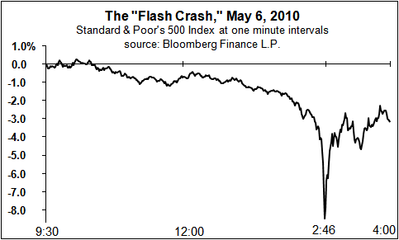

Figure 3: Graph Of S&P 500 Index At 1 Minute Intervals

According to the SEC report (2010), factors ranged from negative market sentiment surrounding the European debt crisis to rising premiums for protection against Greek government debt default, causing a 22.5% increase in the S&P 500 volatility index. Consequently, E-mini-S&P 500 contracts fell by $3.4 billion later that morning. At 2:23 pm, Waddell & Reed triggered an automated sell algorithm, executing a market sell order for 75,000 E-mini futures contracts valued at $4.1 billion. The sell-off order, divided into smaller market orders, was executed at a proportional market rate a minute prior, concluding in 20 minutes (with an execution rate set to 9% of the trading volume). Other HFT algorithms, along with large institutional firms and cross-market arbitrages, immediately bought these contracts, intensively trading among themselves. This elevated trading volume to approximately one-third of the overall volume, prompting the Waddell & Reed algorithm to increase the market order sell rate (SEC report, 2010).

However, the existing sell order had not been fully absorbed into the market, resulting in a liquidity drain and plummeting contract prices to less than 1% of their value the day before. Due to the high selling rate, all HFT algorithms that had purchased the contracts swiftly sold them to other HFTs, initiating a "Hot Potato" effect where nobody wished to retain the contracts at that price due to the surplus supply. By 2:45 pm, the SPY had fallen by 6%, leading the Chicago Mercantile Exchange to pause trading on the E-mini for 5 seconds to prevent further losses and stabilize prices. After the pause, both the E-mini and SP prices rapidly began to recover.

In the aftermath, approximately 2 billion shares were traded in the 20 minutes of the crisis, with over 90% executed at less than 10% of their "pre-crisis" value. The lack of liquidity forced some orders to be sold at prices ranging from 0.1 cents to as high as $100,000. Additionally, the Dow Jones experienced a collapse and recovery of around 9%, equating to a loss and recovery of $1 trillion within a mere 20 seconds.

There has been considerable discourse surrounding the role of HFT algorithms in financial crises. Initially, many attributed the problem to HFTs; however, the CME (Chicago Board of Trade) group's report (2010) on the aftermath of the crisis revealed that the presence of HFTs alleviated a potentially more severe disaster. The report highlighted that HFTs trading in both the spot and derivatives markets were conducting business as usual. Furthermore, the researchers found no evidence to support the claim that Algorithmic and High-Frequency Trading models, operating during the incident, caused the observed market fluctuations. Most importantly, the report asserted that these trading modules improved the situation, providing market efficiencies, liquidity, and price discovery, particularly in markets served by futures.

The researchers emphasized that trading was generally balanced between buyers and sellers at the time of the incident, making it challenging to attribute the declining market action solely to HFTs. Notably, HFTs acted as "shock observers," offering buoyancy to the market during a period when investors and institutional firms were panic-selling and withdrawing liquidity. Unlike human counterparts, HFTs, unswayed by fear, promptly provided the withdrawn liquidity by rapidly buying and selling the dumped securities as prices dropped. This proactive role played by HFTs played a pivotal role in mitigating a more severe disaster. This perspective aligns with academic literature, as affirmed by Hendershott and Riordan (2011), Jones (2013), and Budish, Cramton, and Shin (2015)

# 4. Theory and Hypothesis: Changing Shape of Demand/Bid and Supply/Ask Curves:

To conduct analysis on the market trends and the intraday market impact we use Tesco PLC limit order book data obtained from the London Stock Exchange’s SETS for June to August 2007. This analysis follows the previous work of Malik and Markose (2012), Malik and Wing (2012), and drawing further insights from M. Manjama (2018) on the proposed Measure, NVWAP to construct liquidity supply and demand curves to measure market liquidity dynamics and market impact estimation using nonparametric Kernal regression.

To calculate the NVWAP we firstly calculate the mid-price with Pask as the ask price and P bid the bid price from a limit order book of Tesco PLC stock as follows:

$P_{m}=\frac{P_{bid}+P_{ask}}{2}$ (4.1)

The stock return r is calculated as:

$r=\log{(}P_{m,t+1})-\log{(}P_{m,t})$ (4.2)

Following the assignment guidelines which required picking “3 days and plot a sample of 5 minutely best bids and asks for these three days” the Average Daily Volume (ADV) is calculated as a 3 day moving average of the total transaction volumes for the required 3 months. In building the liquidity demand and supply, following the approach outlined by Malik and Markose (2012), we initially identify reversal points, specifically peaks and troughs, in the cumulative price return for each trading day, utilizing a minimum price return threshold of 25 basis points. Subsequently, for each time *t* corresponding to a cumulative return peak or trough, we capture a snapshot of the order book. In this snapshot, we compute the average expected transaction price for a trade size equivalent to the cumulative volume at the i-th level, denoted as NVWAP (Notional Volume Weighted Average Price), formulated as:

$NVWAP_{i}=\frac{\sum_{j=1}^{i}{P_{j}×Vol_{j}}}{\sum_{j=1}^{i}{Vol_{j}}}$ (4.3)

(3.4) illustrates the calculation, where *i* denotes the cumulative volume level, *Pj*​ represents the price at the *j*-th level, and *Volj*​ is the corresponding volume at the *j*-th level.

The market impact, representing the premium a trader incurs when executing a volume larger than the amount available at the best price, is defined by the formula:

$Y_{i}=\left(\frac{NVWAP_{i}-P_{m}}{P_{b}}\right)×10000$ (4.4)

Additionally, the cumulative volume normalized up to the i-th order at the market side a trader wishes to trade, denoted as Xi, is expressed as:

$X_{i}=\frac{\sum_{j=1}^{i}{Vol_{j}}}{ADV}×100$ (4.5)

Following the approach of Malik and Markose (2012), a regression analysis is conducted, given by:

$\log{(}Y_{i})=\log{β_{0}}+β_{1}X_{i}+ε_{i}$ (4.6)

Here, *β*1​ signifies the slope of the NVWAP curve, capturing the “steepening or flattening” effect of the curves.   
  
The slope in an uptrend of at least 25 basis points: $$∆\log\left({Slope}_{ask}\right)> ∆log⁡({Slope}_{bid})$$ 
and in a downtrend of at least 25 basis points, $$∆\log\left({Slope}_{bid}\right)> ∆log⁡({Slope}_{ask})$$ 
 The change in the curve's slope encapsulates both the available volume and the additional cost or benefit of buying or selling in a rising or falling market (Malik and Markose (2012).

The contraction and Expansion of the NVWAP curves are measured by calculating the total change ($∆\log{(Q)}$) in volume ($Q^{Ask/Bid}$) available on both sides of the limit order book over a predefined interval ((Malik and Markose (2012)).

In an uptrend, the change in volume on the ask side: $$∆\log\left(Q^{Bid}\right)> ∆log⁡(Q^{Ask})$$ 
  
and in a downtrend, the change in volume in the bid side: $$∆\log\left(Q^{Ask}\right)> ∆log⁡(Q^{Bid})$$ 
  
this trend is observed due to the fact that as prices start to rise, investor on the opposite side will compete to consume liquidity quickly (i.e. on the buy on the ask-side and sell on the bid-side) to the advantage of potentially higher returns. This in turn increases the competition and draws higher volume on the demand side at the same time and lowering volume on the supply side.

Malik and Wing (2012) developed a flexible order flow based approach to measuring intraday market impact a limit order book using nonparametric kernel regression. the context of the joint probability density function *f*(*x*, *y*) for the random variables *X* and *Y*, where *X* represents the normalized volume and *Y* denotes the market impact, the conditional expectation of *Y* given *X*=*x* is defined as: $$E\left(Y ∣ X=x\right)=\frac{∫∫y⋅f(x,y)dydx}{∫∫f(x,y)dydx}$$

Here, *f*(*y*∣*x*) represents the conditional probability density function of *Y* given *X*=*x*, and *f*(*x*) is the marginal probability density function of *X*.

To estimate the unknown conditional expectation in Equation (4), the Nadaraya-Watson estimator is employed, as introduced by Nadaraya (1964) and Watson (1964):

$${\hat{m}}_{h}(x)=\frac{\sum_{i=1}^{n}{K_{h}(X_{i}-x)Y_{i}}}{\sum_{j=1}^{n}{K_{h}(X_{j}-x)}}$$

In kernel density estimation using the Gaussian density as the kernel function *K*(⋅), the bandwidth ℎdetermines the smoothness of ${\hat{m}}_{h}$ ​. A robust estimator for *h* is obtained as:

$$\hat{h}=1.06\min\left\{\hat{σ}, \frac{R}{1.34}\right\}n^{{-1}/5}$$

where *R* is the interquartile range and R=X[0.75]-X [0.25]

Furthermore, to analyse how market impact *Y* depends on a vector of exogenous variables *X*, a multivariate Nadaraya-Watson estimator is employed:

$${\hat{m}}_{h}(x)=\frac{\sum_{i=1}^{n}{K_{H}(X_{i}-x)Y_{i}}}{\sum_{j=1}^{n}{K_{H}(X_{j}-x)}}$$

Additionally, a monotonicity constraint is imposed on the regression estimate of market impact, adopting the approach proposed by Dette et al. (2006).  
  
To extend this nonparametric approach for intraday seasonal patterns of market impact dependent on order size and time-of-day, a Nadaraya-Watson estimator is employed with multivariate kernels and monotonicity constraints. The estimation involves analysing the immediate effect of normalized volume (X) on NVWAP and incorporating monotonicity constraints for regression estimates. $$\hat{m}(x)=\frac{\sum_{i=1}^{n}{K_{i}\left(\frac{X_{i}-x}{h}\right)Y_{i}}}{\sum_{i=1}^{n}{K_{i}\left(\frac{X_{i}-x}{h}\right)}}$$

Consider *Yi*​ as the market impact corresponding to the normalized volume *Xi* at the time-of-day *Zi*​. The Nadaraya-Watson estimator can be employed to calculate the seasonal influence of market impact based on the normalized volume *x* at time-of-day *z to finally give us*:

$$\hat{m}\left(x,z\right)=\frac{\sum_{i=1}^{n}{K_{x}\left(\frac{X_{i}-x}{h_{x}}\right)K_{z}\left(\frac{Z_{i}-z}{h_{z}}\right)Y_{i}}}{\sum_{i=1}^{n}{K_{x}\left(\frac{X_{i}-x}{h_{x}}\right)K_{z}\left(\frac{Z_{i}-z}{h_{z}}\right)}}$$

# 5. Construction of Demand and Supply Curves:

In FIGURE 4, we observe the progression of the mid-price and price return spanning June to August 2007. The price movement exhibits distinct phases, including upward trends indicative of a bull market, followed by periods of market decline, signalling a bear market. The figure also illustrates an inverse correlation between booming markets and stock return volatility. Specifically, during a market upswing (boom), volatility remains low, whereas in a bear market characterized by falling stock prices, volatility is notably high. This phenomenon is indicative of the paradox of volatility.

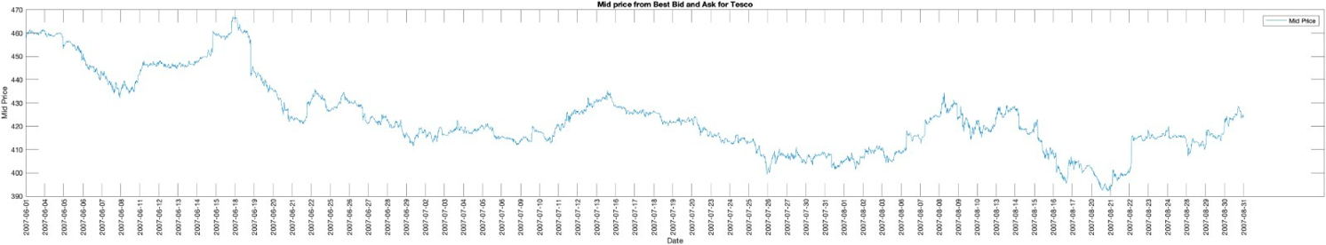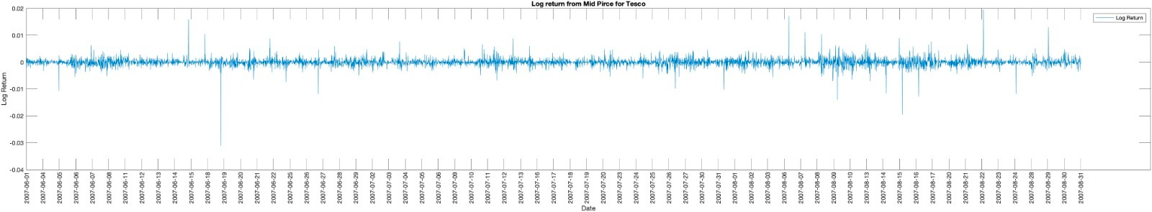

Figure 4

In adherence to the assignment guidelines, which necessitates the selection of "3 days and plot a sample of 5 minutely best bids and asks for these three days," the Average Daily Volume (ADV) is computed as a 3-day moving average of the total transaction volumes over the required three months. To construct liquidity demand and supply, as per the approach outlined by Malik and Markose (2012), reversal points, specifically peaks and troughs, are initially identified in the cumulative price return for each trading day, utilizing a minimum price return threshold of 25 basis points. Subsequently, for each time 't' corresponding to a cumulative return peak or trough, FIGURE 5 illustrates the local peaks and troughs identified in the intraday cumulative price return during the trading days of August 14th, 15th, and 16th, 2007. These identified peaks and troughs serve as both the starting and ending points for each interval, forming the basis for calculating and assessing alterations in the shapes of the NVWAP curves. Consequently, in consecutive intervals, a peak or trough functions as both the endpoint for an uptrend interval and the starting point for the subsequent downtrend interval.

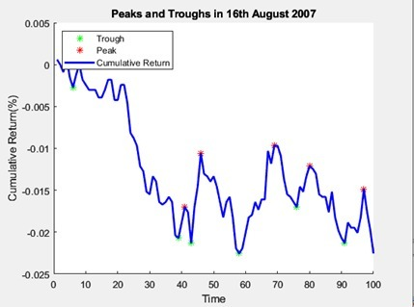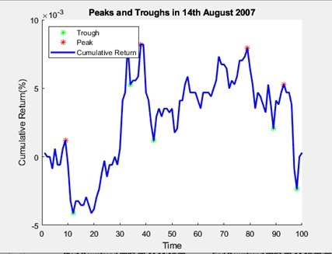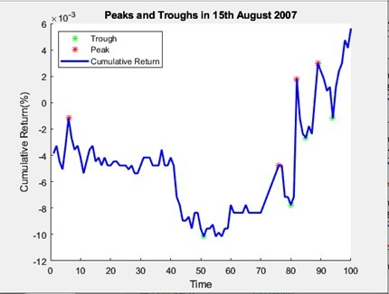

Figure 5

Upon identifying the intervals, FIGURE 6 displays the NVWAP curves for Tesco PLC stock at the commencement and conclusion points during both downtrend and uptrend periods based on the cumulative price return on August 14th, 2007. The top panel illustrates the time stamps for the start and end of a downtrend interval, spanning from 11:10 AM (peak) to 12:00 PM (trough). During this interval, the ask side NVWAP curve gradually expands and flattens, while the bid side NVWAP curve contracts and steepens. The middle panel corresponds to an uptrend interval from 12:00 PM (trough) to 12:40 PM (peak). In contrast to the previous interval, here, the bid side NVWAP curve gradually expands and flattens, while the ask side NVWAP curve contracts and steepens. Similar behaviour is observed in the subsequent intervals, as depicted in the bottom panel, illustrating the uptrend interval from 13:30 (peak) to 14:30 (trough) on August 14th, 2007.

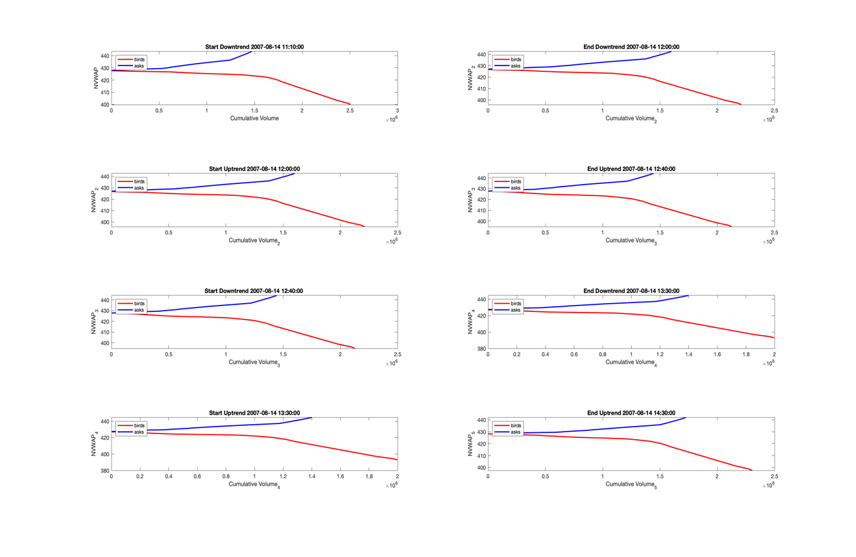

Figure 6

The FIGURE 7-8 illustrates NVWAP curves for HSBC stock on 15th and 16th August 2007, showcasing downtrend and uptrend points. Analyzing these curves aligns with findings from Malik and Markose (2012), Malik and Wing (2012), and M. Manjama (2018). According to their insights, during an uptrend, liquidity supply (ask side) gradually decreases as market price rises, evident in the NVWAP curve's contracting and steepening shape on the ask side. Conversely, the bid side NVWAP curve expands and becomes flatter. This pattern reverses in a downtrend, where the bid side NVWAP curve contracts and steepens, while the ask side NVWAP curve expands and flattens.

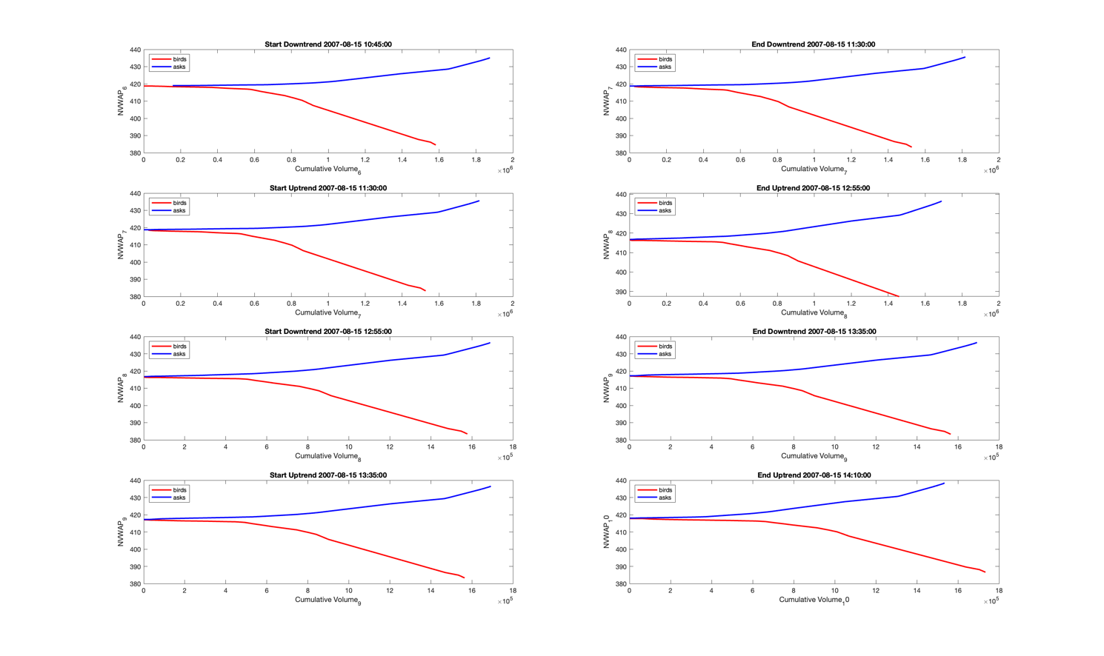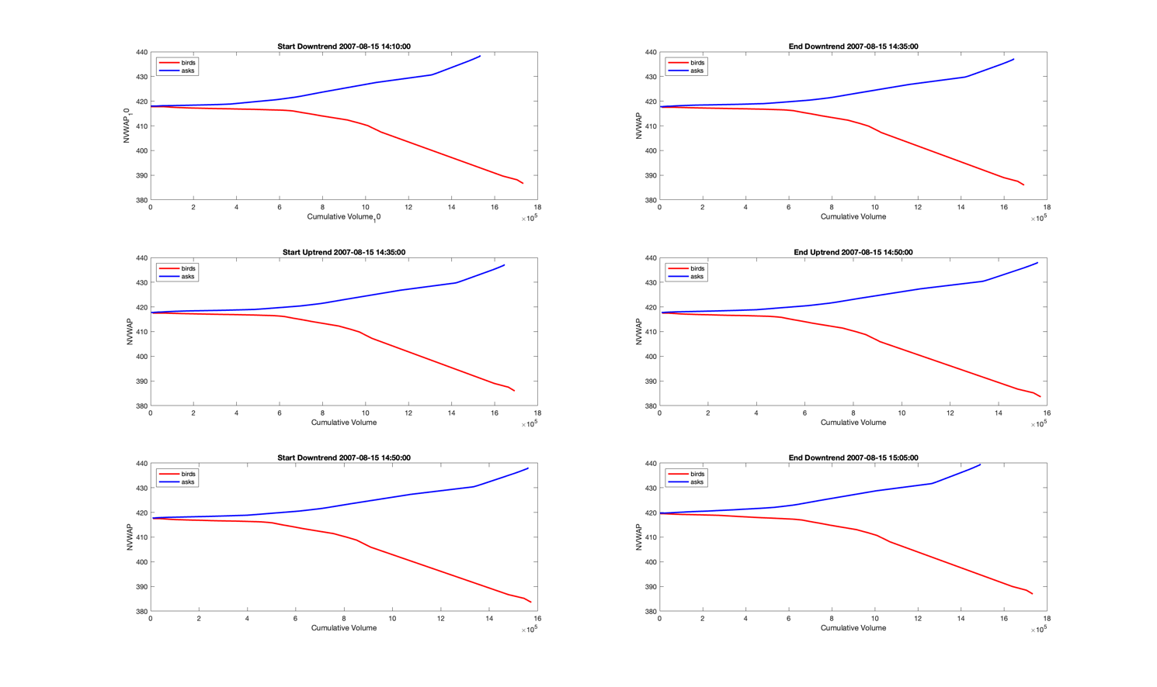

Figure 7

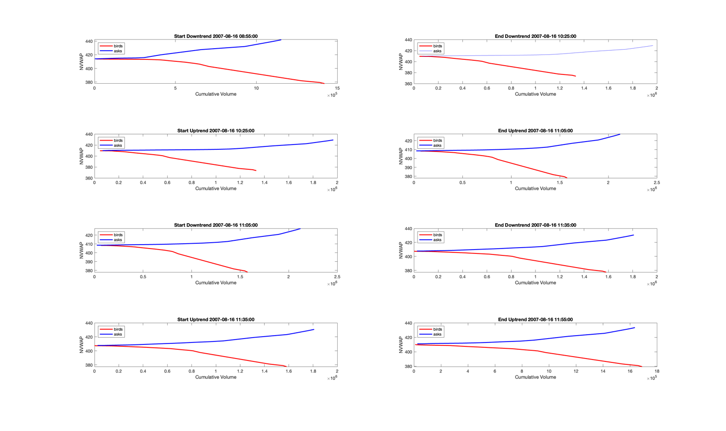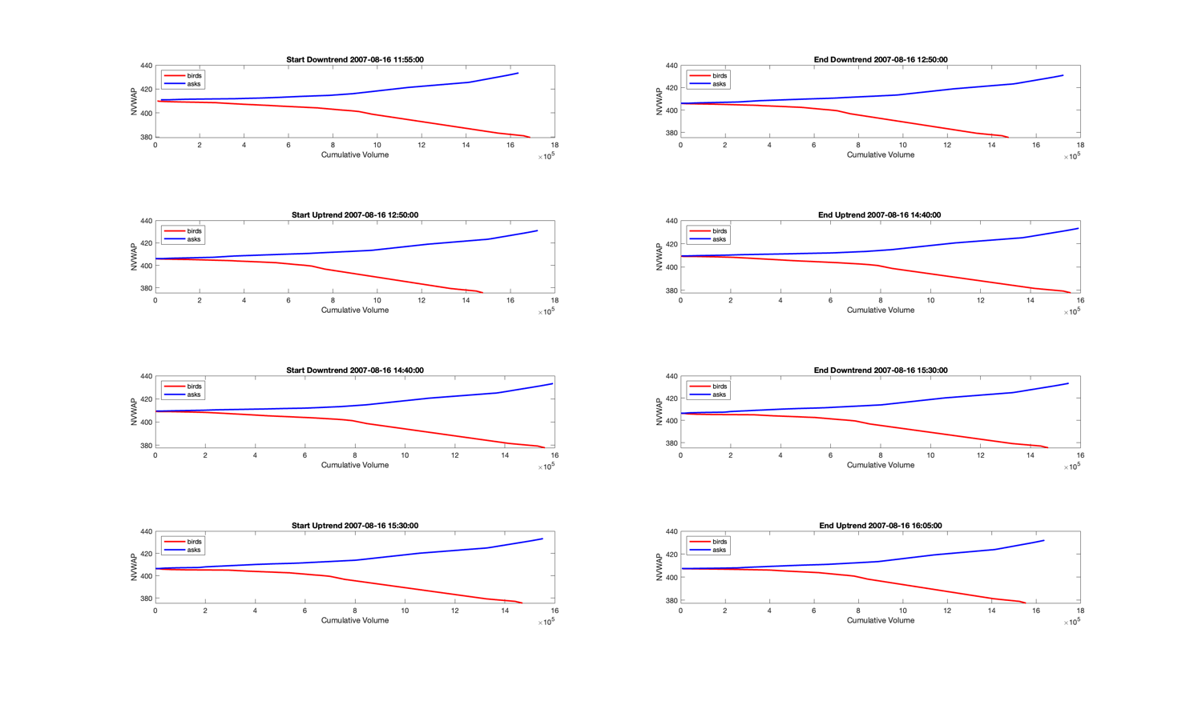

Figure 8

# 6. Conclusion

In summary, our exploration of market microstructure, particularly in the context of the London Electronic Order Book, has shed light on the intricate dance between buyers and sellers. The challenges and opportunities presented by high-frequency algorithmic trading have been analysed, recognizing its role in shaping modern financial markets. The Malik-Markose method has been employed to dissect the changing dynamics of demand and supply curves, providing valuable insights into market liquidity. As we navigate through the nuances of price impact methodology, we discern how order book information serves as a precursor to price trends. This journey underscores the complexity and interplay within market microstructure, urging further research to unravel its depths and refine trading strategies in an ever-evolving financial landscape.

# 7. References

[Malik, A. and Markose (2012) “ Price Trends and Liquidity Dynamics in London SETS Limit Order Book: An Application of Real Time Rebuild of SETS“](https://moodle.essex.ac.uk/pluginfile.php/795372/mod_folder/content/0/Malikand%20MarkoseJan24PriceTrendsAndLiquidityDynamicsInLOBMarkoseandMalik.docx?forcedownload=1)

[Anatoly B. Schmidt (2011) Financial markets and trading an introduction to market microstructure and trading strategies](https://ebookcentral.proquest.com/lib/universityofessex-ebooks/detail.action?docID=697662&pq-origsite=primo)

[Easley,López de Prado, and O’Hara, (2010) “The microstructure of the “flash crash”: Flow toxicity, liquidity crashes and the probability of informed trading”, SSRN Electronic Journal [Preprint]. doi:10.2139/ssrn.1695041.](https://www.researchgate.net/publication/228261179_The_Microstructure_of_the_'Flash_Crash'_Flow_Toxicity_Liquidity_Crashes_and_the_Probability_of_Informed_Trading)

Galhau François et al. (no date) FSR Financial Stability Review - Banque de France, Banque de France. Available at: https://publications.banque-france.fr/sites/default/files/medias/documents/financial-stability-review-20_2016-04.pdf (Accessed: 26 Winter 2023).

Linton, O. and Mahmoodzadeh, S. (2018) ‘Implications of high-frequency trading for security markets’, Cambridge-INET Working Paper Series No: 2018/01 Cambridge Working Papers in Economics: 1802 [Preprint]. doi:10.1920/wp.cem.2018.0618.

[Budish, Cramton and Shin (2015), "The High-Frequency Trading Arms Race: Frequent Batch Auctions as a Market Design Response", *Quarterly Journal of Economics*, 130 (4), 1547-1621](https://moodle.essex.ac.uk/pluginfile.php/795372/mod_folder/content/0/BudishCramptonShimHighFrequencyTradingArmsRace1547.full.docx?forcedownload=1)

[Cliff, D, Brown, D & Treleaven (2011), Technology Trends in the Financial Markets: A 2020 Vision. UK Government Office for Science. Section 43-4, http://www.bis.gov.uk/assets/bispartners/foresight/docs/computer-trading/11-1222-dr3-technology-trends-in-financial-markets.pdf](https://essexuniversity-my.sharepoint.com/personal/eo19181_essex_ac_uk/Documents/EC911%20-%20Computational%20Market%20Microstructure%20for%20FinTech%20and%20the%20Digital%20Economy/EC911%20Term%20Paper/Cliff,%20D,%20Brown,%20D%20&%20Treleaven%20(2011),%20Technology%20Trends%20in%20the%20Financial%20Markets:%20A%202020%20Vision.%20UK%20Government%20Office%20for%20Science.%20Section%2043-4,%20http:/www.bis.gov.uk/assets/bispartners/foresight/docs/computer-trading/11-1222-dr3-technology-trends-in-financial-markets.pdf)

[Cliff, D, Brown, D & Treleaven (2011), Technology Trends in the Financial Markets: A 2020 Vision. UK Government Office for Science. Section 43-4, http://www.bis.gov.uk/assets/bispartners/foresight/docs/computer-trading/11-1222-dr3-technology-trends-in-financial-markets.pdf](https://essexuniversity-my.sharepoint.com/personal/eo19181_essex_ac_uk/Documents/EC911%20-%20Computational%20Market%20Microstructure%20for%20FinTech%20and%20the%20Digital%20Economy/EC911%20Term%20Paper/Cliff,%20D,%20Brown,%20D%20&%20Treleaven%20(2011),%20Technology%20Trends%20in%20the%20Financial%20Markets:%20A%202020%20Vision.%20UK%20Government%20Office%20for%20Science.%20Section%2043-4,%20http:/www.bis.gov.uk/assets/bispartners/foresight/docs/computer-trading/11-1222-dr3-technology-trends-in-financial-markets.pdf)  
  
[Linton, Hara, Zigrand, Cliff, & Hendershott. (2011). Foresight: The Future of Computer Trading in Financial Markets (2012) Final Project Report. The Government Office for Science, London, 28–37, 42–59.](https://moodle.essex.ac.uk/pluginfile.php/795372/mod_folder/content/0/12-1086-future-of-computer-trading-in-financial-markets-report.docx?forcedownload=1)

[London Stock Exchange Electronic Trading System](https://www.londonstockexchange.com/)

M. Manjama (2018): TERM PAPER FOR EC912-7-A EXPERTS SEMINAR SERIES ON ECONOMIC POLICY AND FINANCIAL REGULATION AND GOVERNANCE  
  
  
High frequency trading I: Introduction to market microstructure (no date) QuantStart. Available at: https://www.quantstart.com/articles/high-frequency-trading-i-introduction-to-market-microstructure/ (Accessed: 26 January 2024).

Frey, Stefan; Sandås, Patrik (2009) : The impact of iceberg orders in limit order books, CFR working paper, No. 09-06, University of Cologne, Centre for Financial Research (CFR), Cologne. Available at: <https://www.econstor.eu/bitstream/10419/41392/1/605038759.pdf>

Machowski (2021) An introduction to limit order books, machow.ski. Available at: https://www.machow.ski/posts/2021-07-18-introduction-to-limit-order-books/#iceberg-order (Accessed: Winter 2023).  
  
Zhu, H. (2012) ‘Do dark pools harm price discovery?’, SSRN Electronic Journal [Preprint]. doi:10.2139/ssrn.1712173.

Brogaard, J. and Pan, J. (2021) ‘Dark pool trading and information acquisition’, The Review of Financial Studies, 35(5), pp. 2625–2666. doi:10.1093/rfs/hhab098.  
  
Zheng et al (2013) Zheng, B., Moulines, E. and Abergel, F. (2012) ‘Price jump prediction in Limit order book’, SSRN Electronic Journal [Preprint]. doi:10.2139/ssrn.2026454.   
  
  
----  
Mueller, R.C. (1998) ‘The Venetian money market: Banks, panics, and the public debt, 1200-1500’, Choice Reviews Online, 35(05). doi:10.5860/choice.35-2833.  
  
Smith, B.M. (2004) A history of the global stock market: From ancient rome to Silicon Valley. Chicago, Ill: Univ. of Chicago Press.  
  
Webster, A. (1990) ‘The Political Economy of Trade Liberalization: The East India Company charter act of 1813’, The Economic History Review, 43(3), p. 404. doi:10.2307/2596940.

Dwyer, G.P., Locke, P. and Yu, W. (1996) ‘Index arbitrage and Nonlinear Dynamics between the S&P 500 futures and cash’, Review of Financial Studies, 9(1), pp. 301–332. doi:10.1093/rfs/9.1.301.

Smith, B.M. (2004) A history of the global stock market: From ancient rome to Silicon Valley. Chicago, Ill: Univ. of Chicago Press.

Nasseri, A.A., Tucker, A. and de Cesare, S. (2015) ‘Quantifying stocktwits semantic terms’ trading behavior in financial markets: An effective application of Decision Tree Algorithms’, Expert Systems with Applications, 42(23), pp. 9192–9210. doi:10.1016/j.eswa.2015.08.008.  
  
MABROUK, N. et al. (2022) ‘Intraday trading strategy based on gated recurrent unit and convolutional neural network: Forecasting daily price direction’, International Journal of Advanced Computer Science and Applications, 13(3). doi:10.14569/ijacsa.2022.0130369.  
  
Goldstein, J. and Nost, E. (2022) in The nature of data: Infrastructures, environments, politics. Lincoln: University of Nebraska Press, pp. 23–33.  
  
Fitch (2020) The rise in demand for Quant Professionals: Harnessing New Skills for the future, FE News. Available at: https://www.fenews.co.uk/fe-voices/the-rise-in-demand-for-quant-professionals-harnessing-new-skills-for-the-future/ (Accessed: 12 January 2024).  
  
Duhigg, C. (2008) ‘Stock Traders Find Speed Pays, in Milliseconds’, New York Times.